LORNOAR The BAND

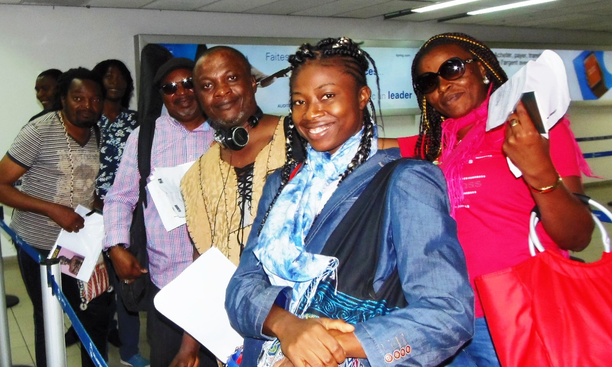

From left to right :
Hervé KUIPO keyboards
Michel MBARGA guitar
Georges ONGUENE Percussions
André MANGA Arranger Band leader
Philippe “JOKER” WANDJI drums
LORNOAR Lead guitar
Bianca choirs

